***ALL***

***ARE***

***WELCOME***

JULY 11 **SUNDERLAND STRING BAND**

 FEATURING COUNTRY MUSIC OF AGES PAST

JULY 18 **SILVAIN CASTELLANO QUARTET**

 JAZZ MUSIC

JULY 25 **DAVE KAYNOR** 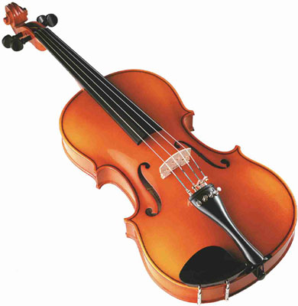

FIDDLIN’ AROUND WITH DAVE and friends

AUGUST 1 **STEVE AND TOM** 

FEATURING SWING MUSIC, EASY LISTENING

RAIN OR SHINE

**WEDNESDAY NIGHT**

**MUSIC ON THE COMMON**

***MONTAGUE CHURCH 4 NORTH STREET***

***MONTAGUE CENTER***

