SPRING FLING

SUPPER

(TAKE OUT)

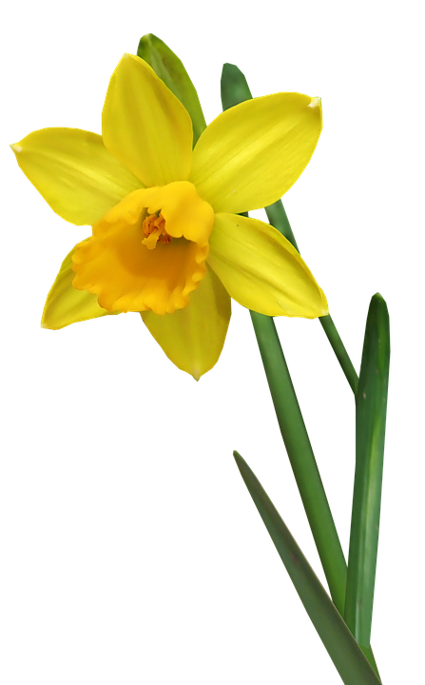



***MONTAGUE CONGO CHURCH***

***4 NORTH STREET***

MENU

Baked Ham w/ Cranberry Glaze

Baked Beans (homemade)

Pickled Beets

Fresh dinner rolls w/ butter

Strawberry Rhubarb Delight

Saturday April 17 5:30-6:30

Reservations: 413-367-2652

Cost: $12.00

